Do you have a child who will be in grade 7 or grade 9 next year?
Did you know?

• Several important vaccines are offered to students in grades 7 and 9 in New
Brunswick

• These vaccines are free

• These vaccines are given at the school by Public Health Nurses

The following vaccines are available to students entering grade 7 or 9:
Grade 7

• All students are offered a vaccine that protects against tetanus, diphtheria, and pertussis (whooping cough).

• Female students only are offered a vaccine that protects against the human papillomavirus (HPV), which is the leading cause of cervical cancer. It will also protect them against viruses responsible for 90 per cent of all genital warts.

Grade 9

• All students in grade 9 are offered a vaccine that protects against 4 types of meningitis.

During the upcoming school year Public Health will distribute information pamphlets to students in grades 7 and 9. Students will be asked to bring these pamphlets home to their parents. It will be important that you read the information, complete and sign the attached consent form and return the consent form to the school with your child. Since girls in grade 7 will be offered two vaccines, they will receive two pamphlets.
If you have any questions regarding this program please contact your local Public Health office. Contact information for each Public Health office is available at www.HorizonNB.ca.

National Immunization Awareness Week 2014
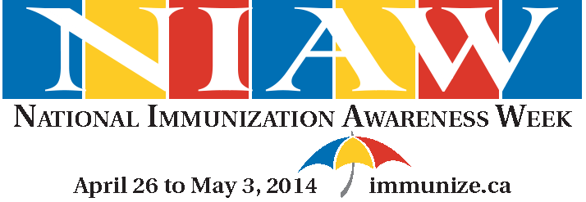

National Immunization Awareness Week takes place from April 26 to May 3, 2014,

