Angles in Quadrilaterals
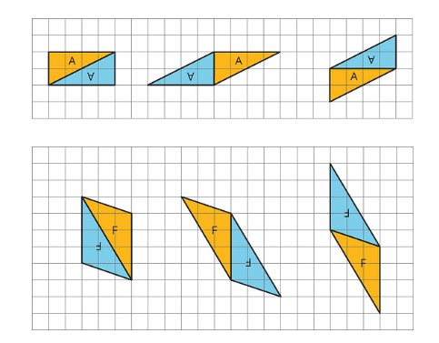
Quadrilaterals are polygons with 4 sides and 4 angles. Each quadrilateral is made of two triangles.

We now know the sum of the interior angles in a triangle is 180 degrees. Therefore, quadrilaterals have an angle sum of 180 X 2= 360 degrees.
We can find missing angles in quadrilaterals using this property.
Example
A quadrilateral has angles 45 degrees, 75 degrees and 150 degrees. The fourth angle must make the total be 360 degrees.
45+ 75+150 + ___ = 360
Add the 3 angles (45+75+ 150) = 270 degrees , then ask yourself what needs to be added to make 360.
Another way is to subtract the sum of the 3 angles from 360. 360-270 = 90 degrees

