ROCK, PAPER, SCISSOR
GAME STATIONS

Notes to instructors:
Rock, Paper, Scissor (RPS) is a fun and useful game that can be played in many ways. The games in this packet were designed for small to medium groups and can be played with a mix of ages. Set up details and game instructions are provided for activity leaders and students. Encourage students to use RPS when facing unresolved issues or group decisions. Let RPS resolve the issue before it becomes a conflict.

Rules to remember: Rock beats scissor, scissor beats paper, paper beats rock

As with any game or activity resource, it is up to you to assess the needs and abilities of the students under your supervision. Modify this game as needed to meet the requirements of your space, group size, and age ranges.

The pages of this packet are designed to be used as station cards. The instructions can be read and explained by older and more mature students. However, we strongly recommend teaching each game to the group before allowing students to work independently.

Every page includes a reminder to practice safe social distancing. All of the games in this packet were designed to allow students to remain a minimum of 6 feet apart and DO NOT require them to use or share equipment.

ROCK, PAPER, SCISSOR
RULES POSTER

Rule 1: All players must use the same cadence for showing their choice (rock, paper, or scissor).
We will use, “1, 2, 3!” As you say “3,” show your choice. If any players don’t follow the cadence, redo the match.

Rule 2: Know who wins by using the RPS value chart below.

ROCK > SCISSOR
SCISSOR > PAPER
PAPER > ROCK

Rule 3: All players must use 1 of the 3 show options: rock, paper, or scissor. See the illustrations below.
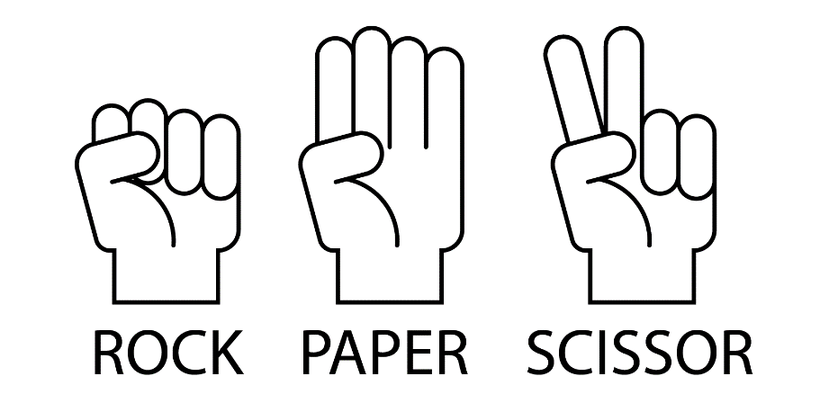

BASIC ROCK, PAPER, SCISSOR (RPS)

Game Set-Up
- Stand 6 feet across from a partner.

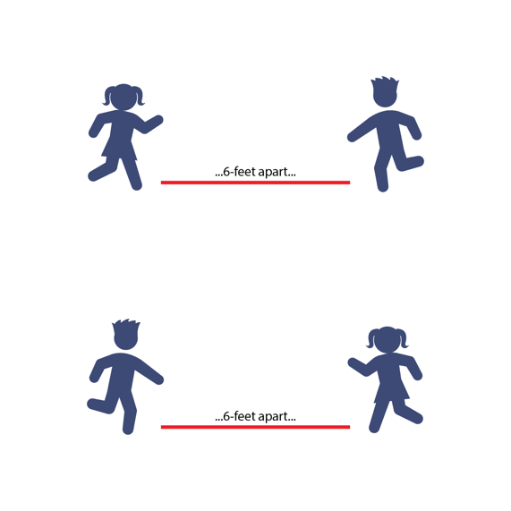
Game Instructions
- The object of RPS is to show an object that is greater in value than what your opponent shows. You have only 3 choices: rock, paper, or scissor. Rock beats scissor. Scissor beats paper. Paper beats rock.
- On the start signal, face your partner with at least 6 feet in between the two of you. Be sure you’re 6 feet from any other pairs as well. At the same time as your partner, say, “1, 2, 3!” As you say “3,” show your RPS choice.
- After each game, find a new partner, stand 6 feet away from them, and play another RPS match. Continue until you hear the stop signal.

VICTORY LAP RPS

Game Set-Up
- Stand 6 feet across from a partner.
- There are cones set up around the activity area. You’ll jog your victory laps around those cones.

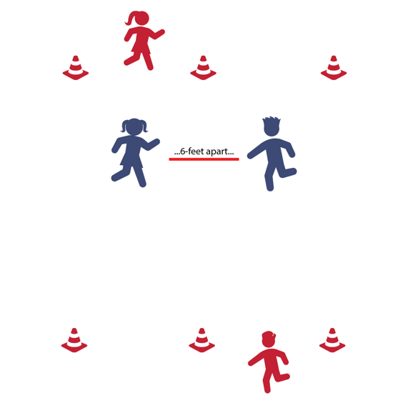
Game Instructions
- The object of Victory Lap RPS is to do as many victory laps as you can before you hear the stop signal.
- On the start signal, stand 6 feet away from a partner and play RPS.
- The winner of the match gets to run 1 victory lap around the cones. When they get back, they’ll find a new partner and play again.
- The player who didn’t win can find a new partner as soon as the match is complete. Keep playing with new partners until you hear the stop signal.

VICTORY DANCE RPS

Game Set-Up
- Stand 6 feet across from a partner.
Game Instructions
- The object of Victory Dance RPS is to do as many victory dances as you can before you hear the stop signal.
- On the start signal, stand 6 feet away from a partner and play RPS.
- The winner of the match gets to do a 10-second victory dance. When they’re finished, they’ll find a new partner and play again.
- The player who didn’t win can find a new partner as soon as the match is complete. Keep playing with new partners until you hear the stop signal.
CHAMPIONSHIP BELT RPS

Game Set-Up
- There are 6 cones set up around the activity area. Each cone is a Championship Belt Station.

Game Instructions
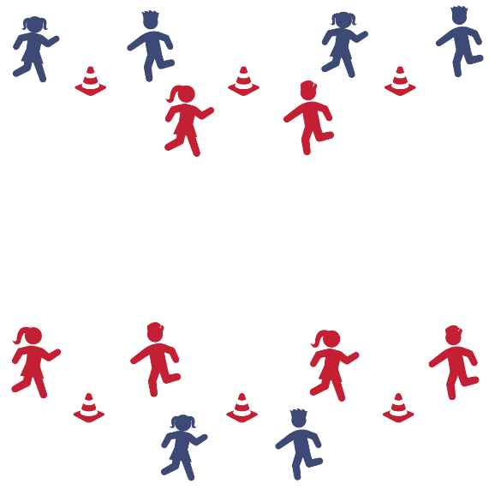
- The object of Championship Belt RPS is to win as many championship belts as you can. You win a belt by winning 3 RPS matches in a row at a cone (Championship Belt Station).
- Start at any Championship Belt Station. Stand 6 feet away from your challenger each time you play.
- On the start signal, play RPS. If you win, stay at that station and find a new challenger to play again.
- If you don’t win, move to another station and begin a new championship run.
- If you win 3 in a row at a station, put on your (invisible) championship belt. Then wear your belt to a new station and begin a new championship run. How many belts can you win?

- If there’s time at the end of the game, all players who have won a championship belt can go head to head to see who wins the Ultimate RPS Championship Belt!
BALANCE POSE RPS

Game Set-Up
- Stand 6 feet across from a partner.

Game Instructions
- The object of Balance Pose RPS is to win as many RPS matches as you can while holding different balance poses.
- On the start signal, choose a balance pose from the bottom of this page. Then play RPS while holding that balance pose. It’s okay if you and your partner choose different poses to begin the game.
- For the next match, the player who wins gets to choose the pose that both players will hold while playing. Continue until you hear the stop signal.

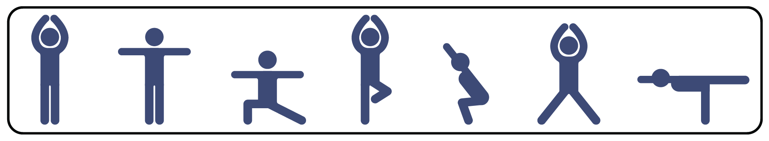
AROUND THE WORLD RPS

Game Set-Up
- There are 6 cones set up around the activity area. Each cone is an Around the World Station.

Game Instructions
- The object of Around the World RPS is to win an RPS match at each cone, traveling “around the world” to 6 Passport Points.
- If you win at a cone (Around the World Station), travel clockwise to the next cone and play a new challenger.
- If you lose at a cone, stay there and find a new challenger. Play again and try to advance.
- If you win at each cone and make it all the way around the world, you earn 6 Passport Points. Keep playing, trying to advance around the world, trying to win as many Passport Points as you can.
STRONG, STRETCH, SWEAT RPS

Game Set-Up
- Stand in a triangle, with 3 partners 6 feet apart from each other.
- Use the Strong, Stretch, Sweat Exercise Chart.

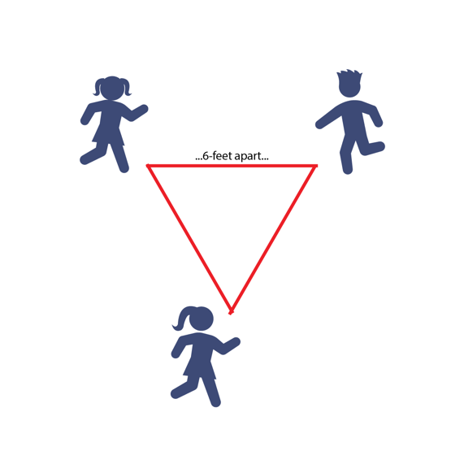
Game Instructions
- The object of Strong, Stretch, Sweat RPS is to complete as many health-related fitness exercises as you can with your partners.
- On the start signal, all 3 players will call out, “Strong, Sweat, Stretch, SHOW!” As you say “show,” all 3 players will show rock, paper, or scissor.
- If 2 or 3 players show the same object, that object “wins” and all players will perform the exercise in that category from the exercise chart.
- If each player shows a different symbol, then each will perform the exercise from the category matching their own symbol.

Rock = Strong / Muscular Fitness
Paper = Stretch / Flexibility
Scissor = Sweat / Aerobic Capacity

STRONG, STRETCH, SWEAT
EXERCISE CHART

STRONG  ROCK | Exercise:  10-Second Plank Hold  (or) 5 Push-Ups
STRETCH  PAPER | Exercise:  Hamstring Stretch  (or) Shoulder Stretch
SWEAT  SCISSOR | Exercise:  15 Jumping Jacks  (or) 30 Invisible Jump Ropes

